* **About the Department:**

Department of Microbiology

Mahatma Gandhi Sarvodaya Sangh’s

PadmashriManibhai Desai Mahavidyalaya, Uruli Kanchan

Affiliated to Savitribai Phule Pune university

* **Departmental Overview:**

Established in **2002**, the **Department of Microbiology** has grown into a vibrant academic unit committed to excellence in teaching, learning, and research. With an **annual intake of 120 students**, the department offers a comprehensive **three-year undergraduate program (B.Sc. Microbiology)** that equips students with in-depth knowledge and practical skills in various fields of microbiology.

Since its inception, the department has been committed to producing skilled microbiologists capable of contributing to diverse sectors such as healthcare, pharmaceuticals, biotechnology, food and dairy industries, environmental management, and scientific research. Through continuous improvement and innovation, the Department of Microbiology strives to nurture responsible, knowledgeable, and employable graduates who can address current and emerging challenges in the microbial world.

* **Highlights:**
* ICT-enabled and experiential teaching-learning practices
* Mentor–Mentee and Class Guardian system for academic and personal guidance
* Strong industry collaboration for internships, projects, and placements
* Regular guest lectures, industrial visits, departmental activities, model and poster competition,Quiz competition
* Focus on innovation, skill enhancement, and holistic student development
* Certificate courses in Biofertiliser Production, Mushroom Production and Cultivation, Milk Adulteration
* **Infrastructure :**
* The Department of Microbiology is well-equipped with modern infrastructure to support effective teaching, hands-on training, and research.
* Spacious and well-ventilated classrooms equipped with projectors, boards, and audio-visual aids.
* The department has**fully functional and specialized laboratories** for undergraduate training and student research
* Modern instruments and equipment available in the department include:

1. Autoclaves and Laminar Air Flow Cabinets
2. Incubators
3. Centrifuge
4. pH Meters and Colorimeters
5. Gel Electrophoresis Unit
6. Hot Air Oven and Rotary Shaker
7. Microscopes: Light, Compound

* **Objective:**
* To impart comprehensive knowledge and practical skills in microbiology
* nurturing students with scientific temper, critical thinking, and ethical values to prepare them for careers in research, healthcare, industry, and higher education.
* **Vision:**

To be a center of excellence in microbiological education and research, fostering innovation, sustainability, and societal impact through scientific advancement and skilled human resource development.

* **Mission:**

1. To provide a strong foundation in microbiological concepts through high-quality teaching and hands-on laboratory training.
2. To encourage curiosity-driven learning and promote research aptitude among students.
3. To develop competent microbiologists capable of contributing to healthcare, agriculture, environment, and industry.
4. To instill values of scientific ethics, environmental responsibility, and lifelong learning.
5. To establish collaborations with academic, research, and industrial organizations for student development and knowledge exchange.

* **Staff Details**

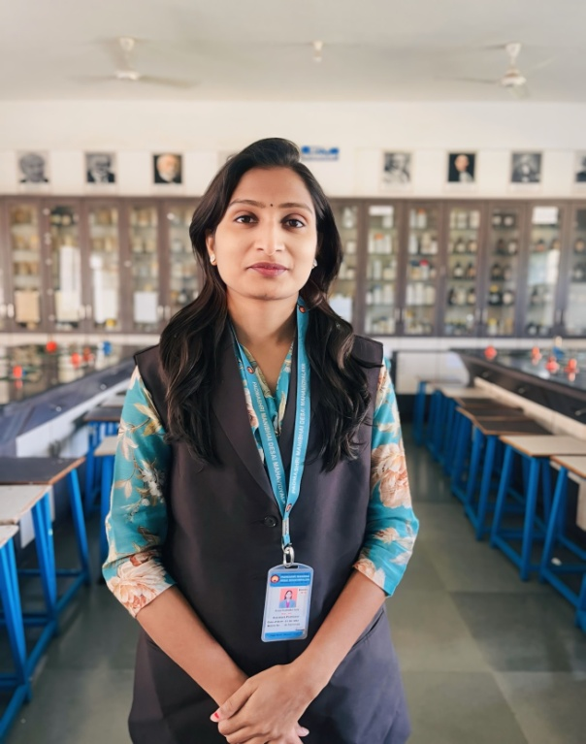**Name:** Anuja Sudhakar Zate

**Designation:** Head of the Department

**Qualification:** B.Sc. Microbiology, M.Sc. Microbiology**,** SET

**Email ID**: [anujazate122@gmail.com](mailto:anujazate122@gmail.com)

**Contact No:** 9175275168

**Experience (in Years):** 9 Years

**Expert Area:** Genetics, Agriculture, Molecula Microbiology, Food Microbiology

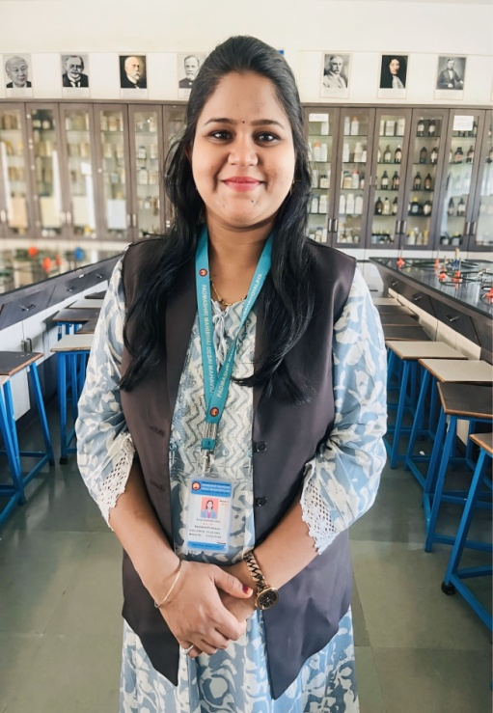**Name:** Pratiksha Dilip Kodre

**Designation:** Assistant Professor

**Qualification:** B.Sc. Microbiology, M.Sc. Microbiology**,**DMLT, Post Graduate Diploma in Clinical Research

**Email ID**: [kodrepratiksha@gmail.com](mailto:kodrepratiksha@gmail.com)

**Contact No:** 8600742592

**Experience (in Years):** 5 Years

**Expert Area:** Medical Microbiology,FermentationTechnology, Air and Water Microbiology

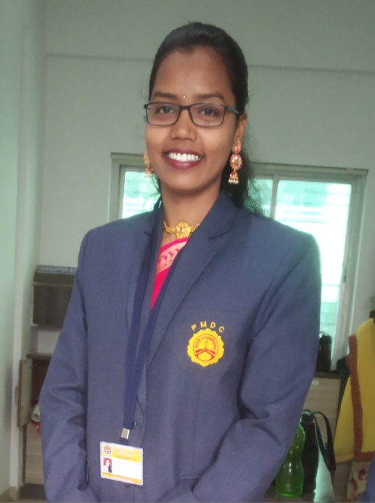

**Name:**Swati Dnyaneshwar Masalkar

**Designation:** Assistant Professor

**Qualification:** B.Sc. Microbiology, M.Sc. Microbiology**,**B.Ed

**Email ID**: [swatidm96@gmail.com](mailto:swatidm96@gmail.com)

**Contact No:** 7758897713

**Experience (in Years):** 6 Years

**Expert Area:**Immunology, Enzymology, Bacterial Physiology

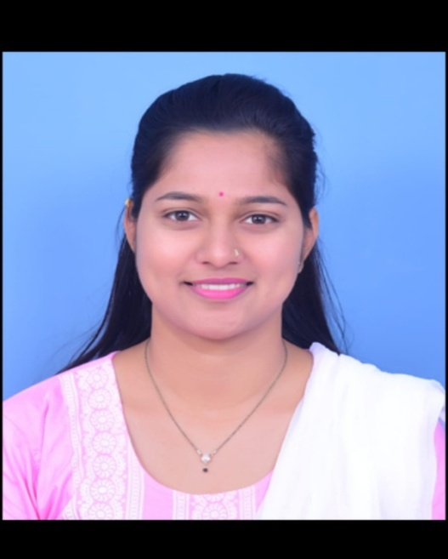**Name:** Vrushali Prafull Mahadik

**Designation:** Assistant Professor

**Qualification:** B.Sc. Microbiology, M.Sc. Microbiology

**Email ID**: [vrushaliprafull5454@gmail.com](mailto:vrushaliprafull5454@gmail.com)

**Contact No:** 9854375454

**Experience (in Years):** 0.4 Years

**Expert Area:** Dairy Microbiology, Marine Microbiology, Nanobiotechnology

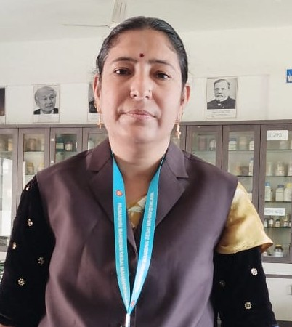

**Name:** Seema Rajendra Visnagarkar

**Designation:** Lab Attender

**Qualification:** HSC

**Email ID**: [seemavishnu12@gmail.com](mailto:seemavishnu12@gmail.com)

**Contact No:** 8329524068

**Experience (in Years):** 6 Years

**Photos of Infrastructure**

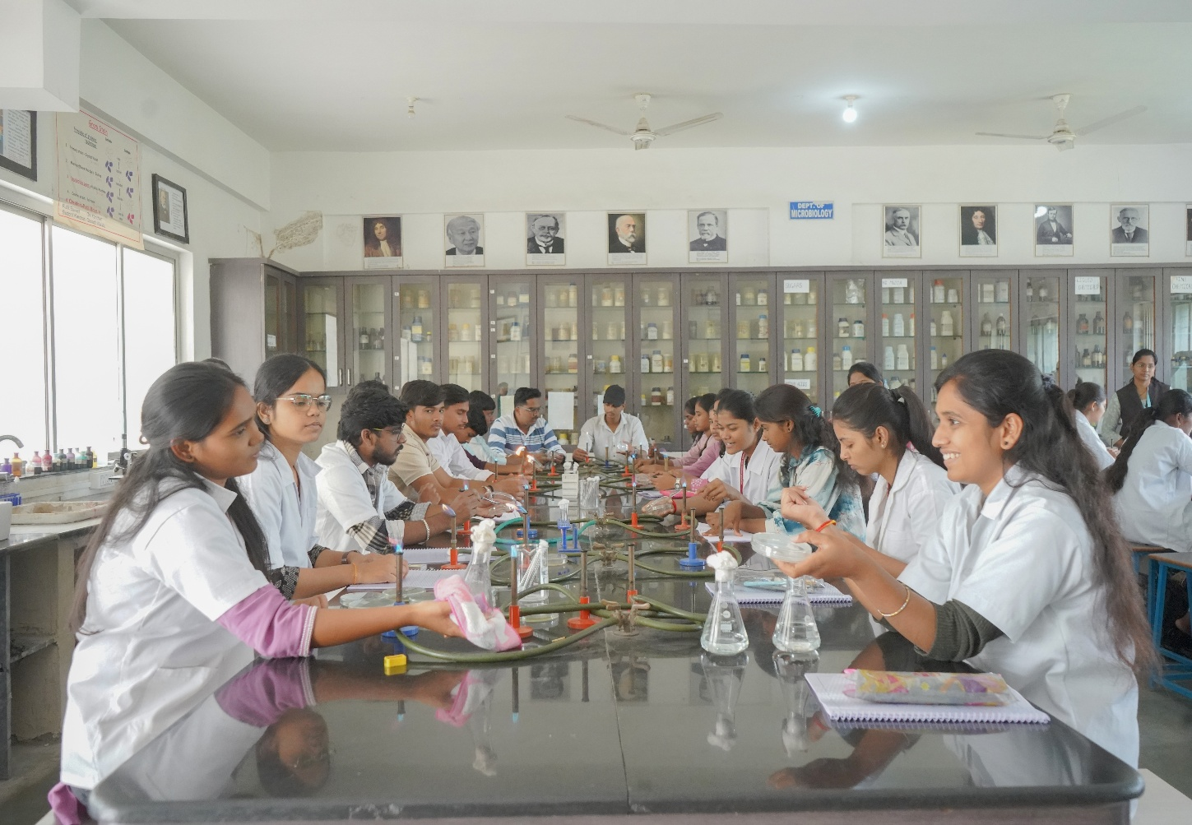

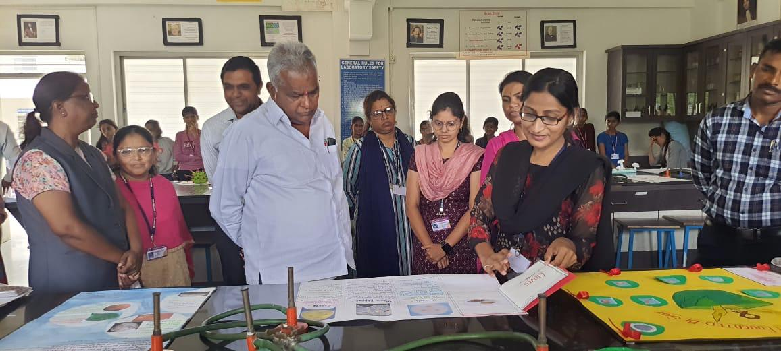

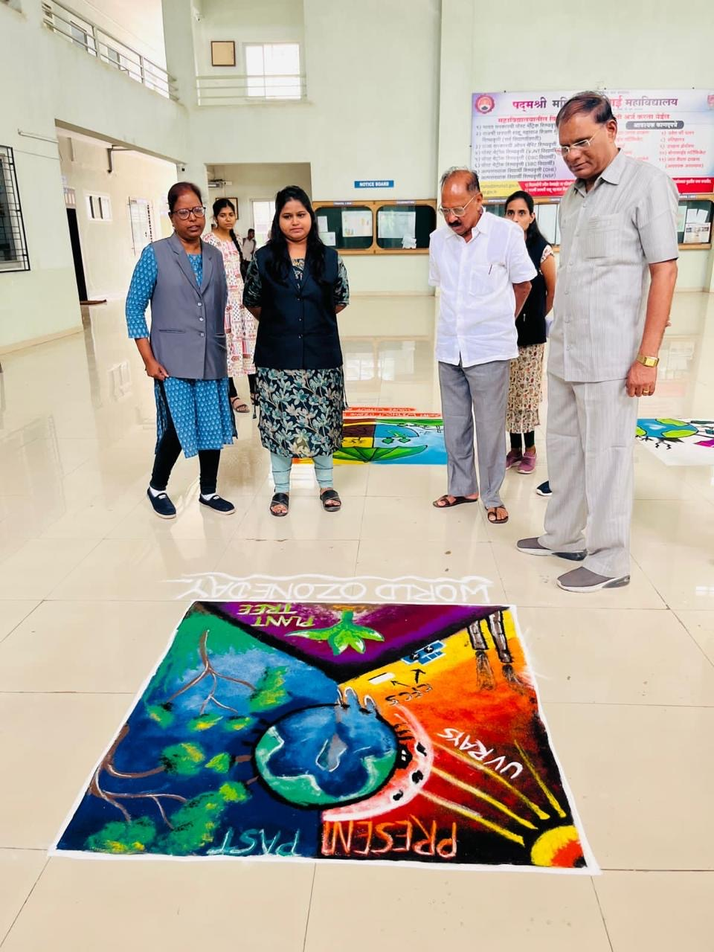

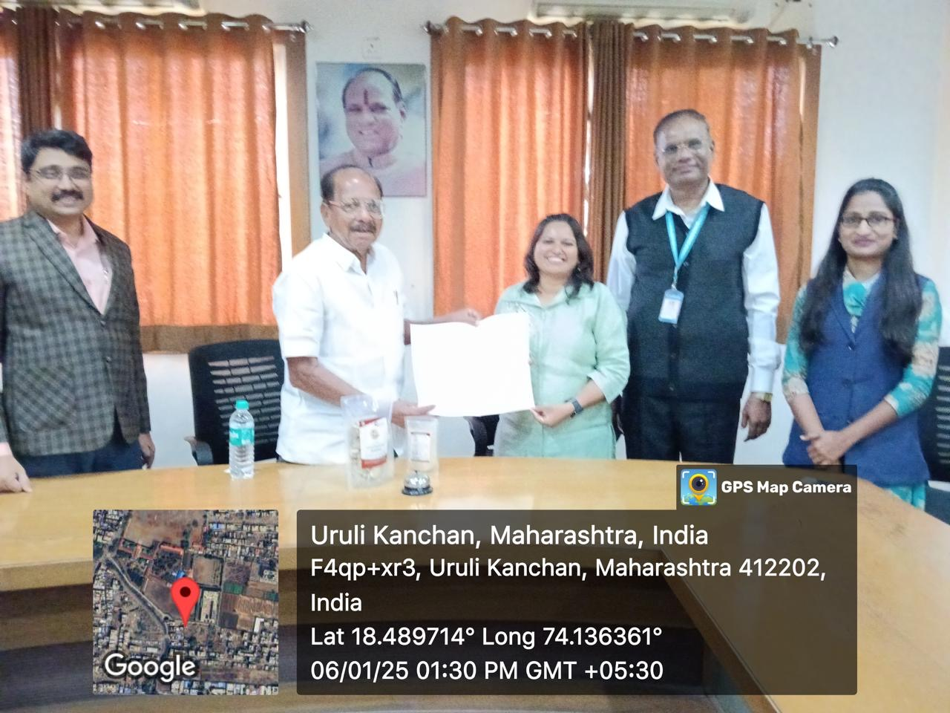

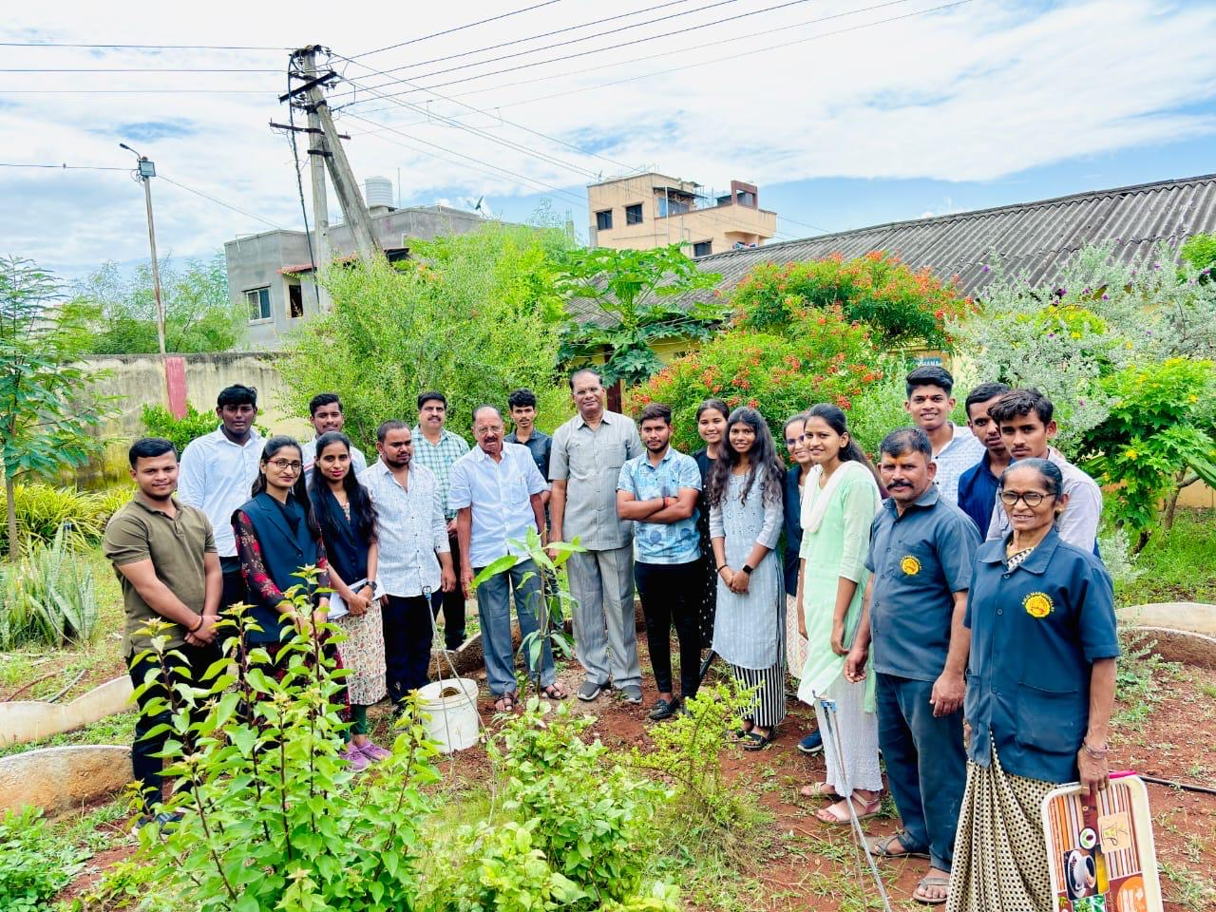

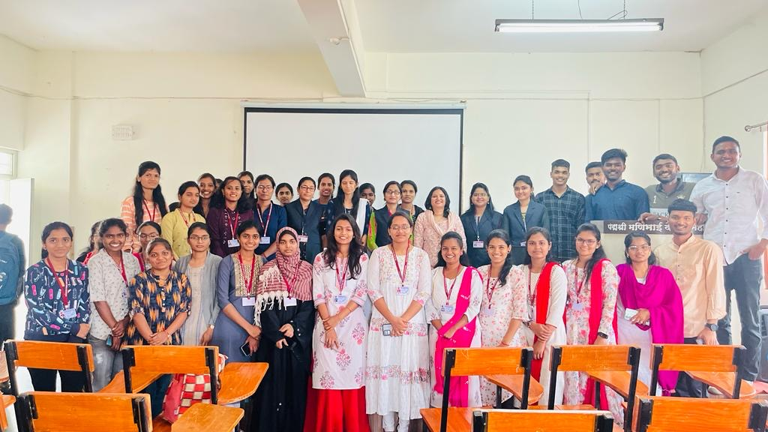

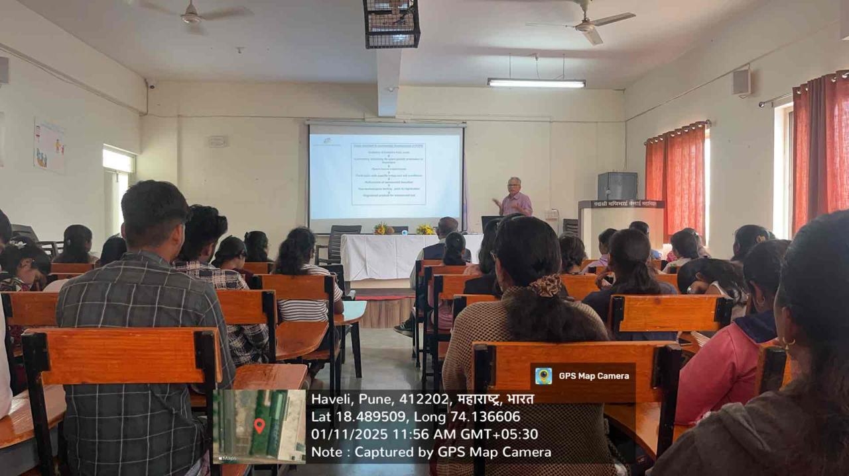

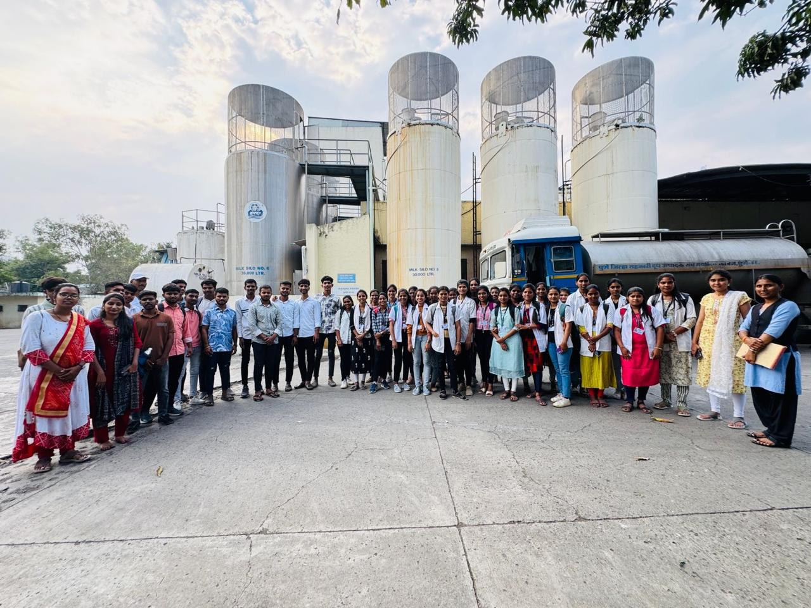

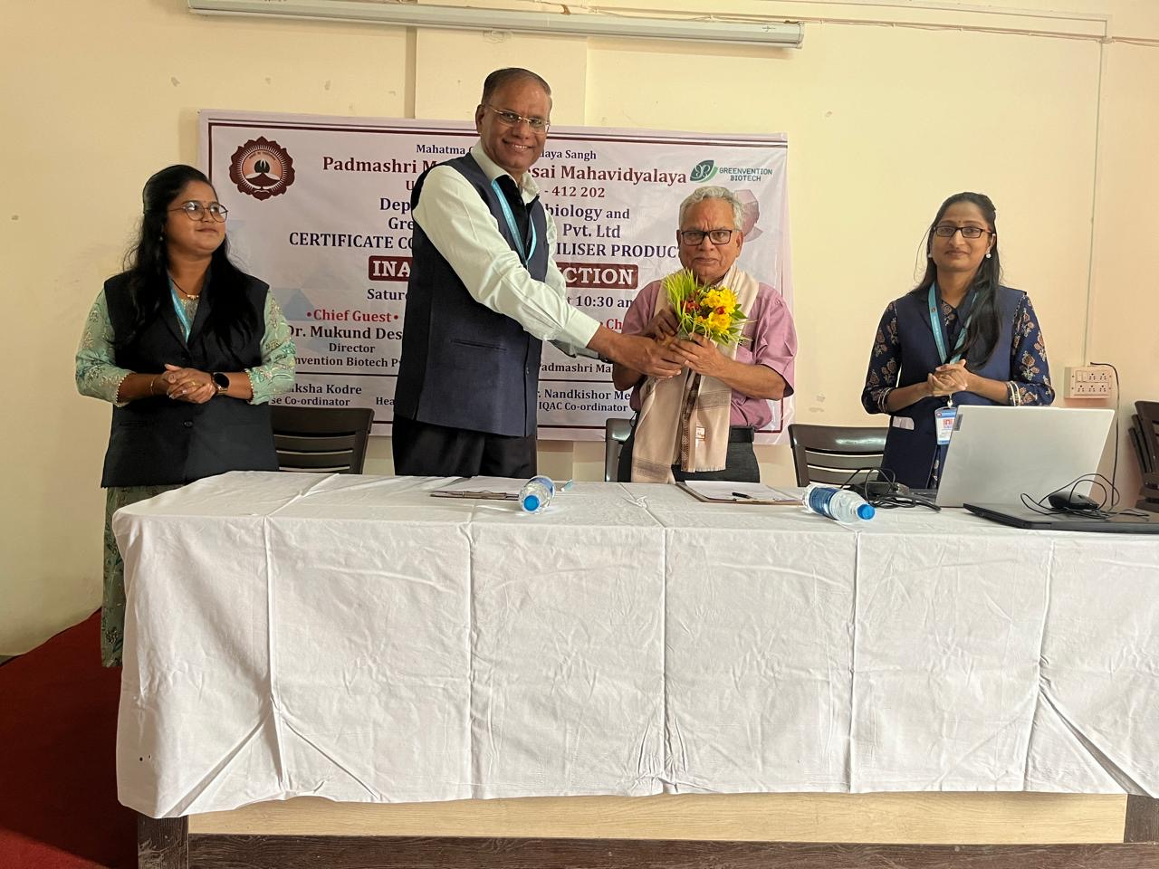

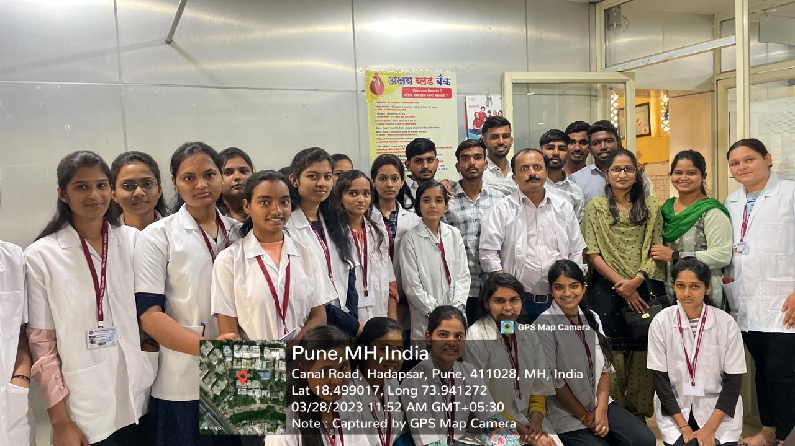

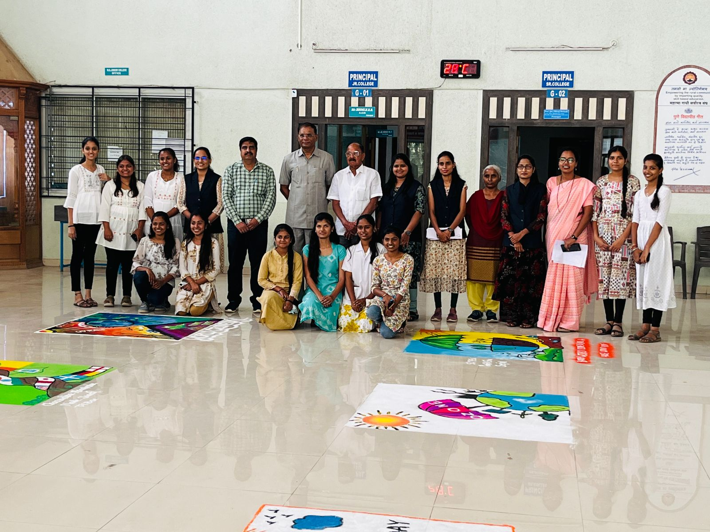

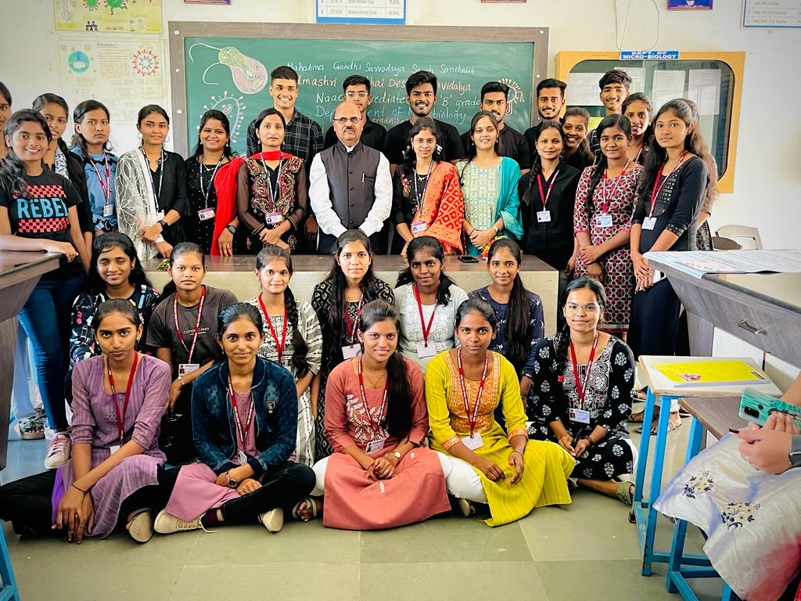

* **Research Paper-**

|  |  |  |  |  |  |  |  |
| --- | --- | --- | --- | --- | --- | --- | --- |
| **Sr.No.** | **Name of Faculty** | **Workshop/Seminar/Conference** | **Level (National/International/State)** | **Activity**  **(Participation/**  **Paper**  **Presentation** | **Journal Name** | **ISBN/ISSN No.** | **Title of Paper** |
| 1 | Prof. Anuja Zate | Conference | International | Paper Presentation | International  Journal of  Multifaceted and  Multilingual  Studies | 978-81-984753-50 | Study on antimicrobial property of *Agaricus bisporus* |
|  | Prof. Anuja Zate |  | International | Paper Publish | International  Journal of  Recent Scientific Research | 978-81-984753-50 | An attempt to reduce the fermentation time for making idlis faster |
|  | Prof. Anuja Zate | Seminar | State | Participation |  | 978-81-984753-50 | Ancient Groves and Modern Science: Bridging Wisdom in Conservation |
| 2 | Prof.Pratiksha Kodre | Conference | International | Paper Presentation | International  Journal of  Multifaceted and  Multilingual  Studies | 978-81-984753-50 | Soil and its role in Sustainable Ecosystem |
|  | Prof.Pratiksha Kodre | Conference | International | Paper Presentation | Sustainable Development’;Conference Proceedings | 978-81-984753-50 | Isolation of fungi Producing pigment and Characterization of pigment |
|  | Prof.Pratiksha Kodre | Conference | National | Participation |  |  | Recent Studies in Applied Sciences |
|  | Prof.Pratiksha Kodre | Seminar | State | Participation |  |  | Ancient Groves and Modern Science: Bridging Wisdom in Conservation |
| 3 | Prof.Swati Masalkar | Conference | International | Paper Presentation | International  Journal of  Multifaceted and  Multilingual  Studies | 978-81-984753-50 | Development and Formulation of natural room freshener from *Azadirachta indica* |
|  |  |  |  | Paper Publish | Gorteria Journal | 0017-2294 | MICP For Sustainable Green Environment |
|  |  | Seminar | State | Participation |  |  | Ancient Groves and Modern Science: Bridging Wisdom in Conservation |

* **Book Publish -**

|  |  |  |  |  |
| --- | --- | --- | --- | --- |
| **Sr.No** | **Name of Teacher** | **Book Name** | **ISBN/ISSN No.** | **Name of Publisher** |
| 1 | Prof.Zate.A.S | Food and Dairy Microbiology | 978-93-5473-221-8 | International Journal of Microbial Science |
|  |  | Fermentation Technology and Agricultural Microbiology Practical Handbook | 978-93-93337-17-7 | International Journal of Microbial Science |
|  |  | MB-3510 Marine Microbiology | 1675371178 | International Journal of Microbial Science |
| 2 | Prof.Masalkar.S.D | Immunology I | 978-93-54-73-210-2 | International Journal of Microbial Science |
|  |  | Fermentation Technology and Agricultural Microbiology Practical Handbook | 978-93-93337-17-7 | International Journal of Microbial Science |
|  |  | MB-3510 Marine Microbiology | 1675371178 | International Journal of Microbial Science |

* **Course Structure-**

|  |  |  |  |  |
| --- | --- | --- | --- | --- |
| **Sr.No** | **Course Name** | **Course Details** | **Pattern** | **Syllabus** |
| 1 | [B.Sc](http://b.sc). Microbiology | Bachelor of Science in Microbiology | NEP Pattern | http://collegecirculars.unipune.ac.in/sites/documents/Syllabus2025/S.Y.B.Sc.%20(Microbiology)_14082025.pdf |
|  | [B.Sc](http://b.sc). Microbiology | Bachelor of Science in Microbiology | NEP Pattern | http://collegecirculars.unipune.ac.in/sites/documents/Syllabus2025/S.Y.B.Sc.%20(Microbiology)_14082025.pdf |
|  | [B.Sc](http://b.sc). Microbiology | Bachelor of Science in Microbiology | CBCS Pattern | http://collegecirculars.unipune.ac.in/sites/documents/Syllabus2021/T.%20Y.%20B.%20Sc.%20(Microbiology)_18102021.pdf |

* **Key Highlights & Best Practices:**

**• Class Guardian and Mentor-Mentee System:**

A structured mentoring program to ensure personalized academic and emotional supportto each student**.**

**• Remedial and Bridge Courses:**

Special sessions conducted for academically weaker students.

**• Skill Enhancement Courses:**

certification courses in Biofertiliser Production, Mushroom Production and Cultivation, Milk Adulteration, Food Preservation.

.**• Industry Collaboration:**

Strategic MoUs with companies and training institutes to facilitate student

internships, live projects, and placements.

**• Guest Lectures and Industry Talks:**

Regular sessions conducted by industry professionals to keep students updated with the

practices.

* **Teaching Pedagogy:**

The Department of Microbiology follows a **student-centric and multidisciplinary teaching pedagogy** that promotes critical thinking, practical application, and scientific curiosity. The teaching approach blends **theoretical knowledge** with **practical exposure**, preparing students for academic, research, and industrial roles. Faculty adopt innovative strategies including:

* Interactive lectures and concept-based teaching
* Problem-solving sessions and group discussions
* Case studies and scenario-based learning
* Project-based learning and research assignments
* Inquiry-based learning to nurture curiosity and exploration
* **ICT Integration in Teaching:**

To enhance the quality of education and student engagement, the department extensively uses **Information and Communication Technology (ICT)** tools. This integration supports blended and remote learning while also promoting digital literacy.

Key ICT practices include:

* Use of **projectorsand multimedia presentations** during lectures
* **Online platforms** such as Google Classroom, Zoom, and Microsoft Teams for classes and assignments
* Use of **educational videos, animations, and interactive tools** to explain complex microbiological processes
* Digital quizzes, and presentations
* **Laboratory & Practical Work:**

Practical training is a core component of the B.Sc. Microbiology program. The department maintains **well-equipped laboratories** that meet academic and safety standards. Practical sessions are designed to complement theoretical learning and develop essential technical skills.

Key features:

* Regular laboratory sessions on microbial staining, culturing, biochemical testing, and sterilization techniques
* Experiments in immunology, molecular biology (electrophoresis), and environmental microbiology
* Training in **handling laboratory equipment**, aseptic techniques, and documentation
* Encouragement for students to conduct **minor and major research projects**
* Emphasis on **lab safety, record keeping**, and adherence to scientific protocols
* **Assessment & Evaluation:**

A transparent and continuous assessment system is followed to track academic progress and skill development. The department uses **formative and summative evaluation methods**:

* **Internal Assessments**: Class tests, unit tests, assignments
* **Practical Examinations**: Evaluation based on lab work, viva voce, and experimental skills
* **Semester Examinations**: As per university norms
* **Project Evaluation**: Based on proposal, execution, report writing, and presentation
* **Participation and performance** in seminars, group discussions, and activities also contribute to internal evaluation
* **Co-Curricular and Extra-Curricular Activities:**

The Department of Microbiology encourages holistic development by organizing and promoting various **co-curricular and extra-curricular activities**:

**Co-Curricular Activities**

* **Student seminars, presentations**
* **Guest lectures** by experts from academia, industry, and research institutes
* **Industrial visits and field trips** to Blood Banks , food industries, research labs, etc.
* Participation in **inter-collegiate science competitions**, exhibitions, and quizzes

**Extra-Curricular Activities**

* Involvement in **college-level clubs and committees** (e.g., NSS, Cultural Club)
* Participation in **sports, cultural fests**
* Organization of **departmental events, microbiology day, awareness drives**, and health camps

These activities help students build confidence, leadership skills, teamwork, and a sense of social responsibility.